Project Design Phase-II
Technology Stack (Architecture & Stack)

Date | 13 March 2026
Team ID | 69c0f3ed43b2af737d05d88d
Project Name | Smart Library Request Workflow in ServiceNow
Maximum Marks | 4 Marks

Technical Architecture
The Smart Library Request Workflow is designed as a cloud-based service management application using ServiceNow as the main platform. It integrates user-facing interfaces with backend workflows, automated approvals, and database storage for tracking requests, issuance, and reporting.

Key Features of the Architecture:
- User Layer: Web-based interface accessible via desktop and mobile browsers.
- Application Layer: ServiceNow platform handles workflows, approvals, notifications, and business logic.
- Integration Layer: APIs for email notifications and authentication (Gmail, LinkedIn).
- Database Layer: ServiceNow's cloud database for storing user and request data.
- Reporting Layer: Dashboard and analytics for library admin.

Reference: IBM Pandemic Order Processing Example 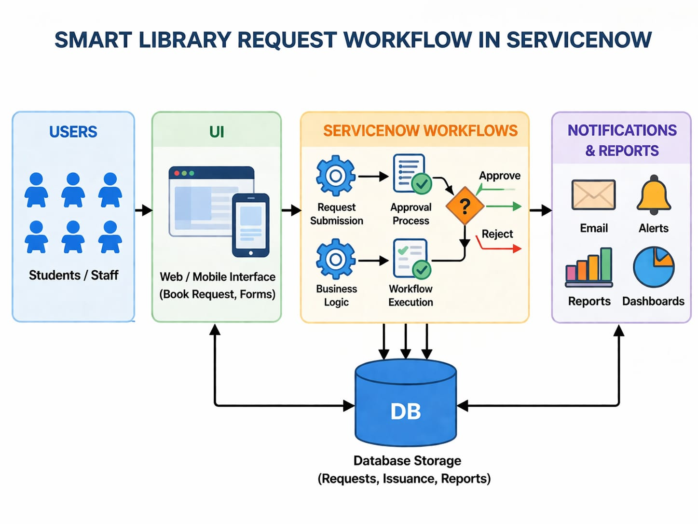
Table-1: Components & Technologies
S.No | Component | Description | Technology / Tool Used
1 | User Interface | How users interact with the library workflow | ServiceNow Web UI, HTML, CSS, JavaScript
2 | Application Logic-1 | Workflow automation for book requests | ServiceNow Flow Designer, Business Rules
3 | Application Logic-2 | Approval process for librarian | ServiceNow Approval Engine
4 | Application Logic-3 | Notifications and email triggers | ServiceNow Notification Engine, Gmail API
5 | Database | Storage for user profiles, requests, book info | ServiceNow Cloud Database (MySQL variant)
6 | Cloud Database | ServiceNow backend cloud DB for scalability | ServiceNow Cloud Database
7 | File Storage | Store attachments like request forms | ServiceNow Attachment Storage
8 | External API-1 | User authentication via Gmail | Google OAuth API
9 | External API-2 | User authentication via LinkedIn | LinkedIn OAuth API
10 | Machine Learning | Optional: Suggest books based on user history | Python ML model / ServiceNow Predictive Intelligence
11 | Infrastructure | Application Deployment on cloud | ServiceNow Cloud, Multi-region deployment

Table-2: Application Characteristics
S.No | Characteristics | Description | Technology / Tool Used
1 | Open-Source Frameworks | Frontend customization using HTML, CSS, JavaScript frameworks | AngularJS / ReactJS
2 | Security Implementations | User authentication, role-based access, encrypted data, secure OAuth for Gmail/LinkedIn | SHA-256, HTTPS, OAuth2, ServiceNow ACLs, OWASP Best Practices
3 | Scalable Architecture | 3-tier architecture with cloud backend, microservices workflow-ready | ServiceNow Cloud, Microservices-ready Flow Designer
4 | Availability | Distributed servers and cloud redundancy ensure high availability | Multi-region ServiceNow Cloud, Load Balancers
5 | Performance | Efficient request handling, caching, notifications optimized, minimal page load time | ServiceNow Cache, CDN for attachments, Async workflows

References:
- C4 Model for Software Architecture
- IBM Online Order Processing System during Pandemic
- IBM Cloud Architecture
- AWS Cloud Architecture
- Technical Architecture Diagrams Guide

